ii) Compare the P&O MPPT performance in Section 5.7 against the identified true MPPs in Section 5.1.

Between sections 5.1 and 5.7, we have two common sets of data which we are able to accurately compare in order to draw conclusions about the P&O MPPT performance. These are the 0.4 and 0.5 A current limits, which can be seen below.

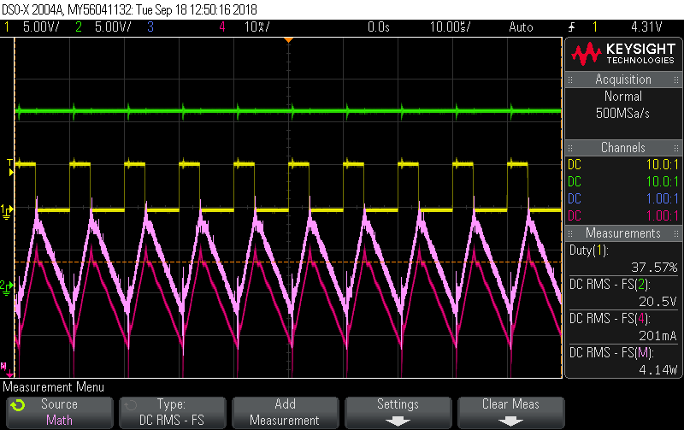

Figure 1: P&O MPPT for 0.4 A current limit (low end)

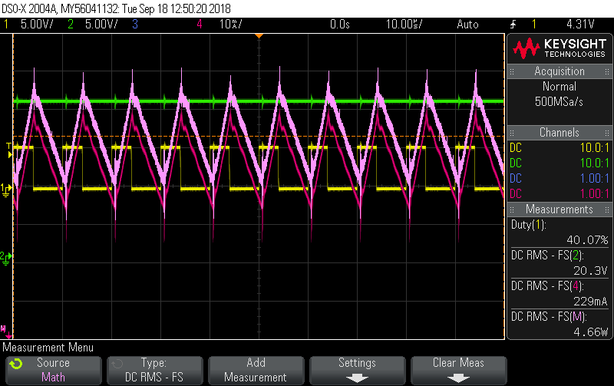

Figure 2: P&O MPPT for 0.4 A current limit (high end)

|  |  |  |  |
| --- | --- | --- | --- |
|  | **0.4 A** |  |  |
| **R(Ω)** | **I (A)** | **v(V)** | **P(W)** |
| 0 (SC) | 0.4 | 0 | 0 |
| 1 | 0.4 | 0.5 | 0.2 |
| 4.7 | 0.4 | 1.88 | 0.752 |
| 10 | 0.4 | 4.03 | 1.612 |
| 22 | 0.4 | 8.75 | 3.5 |
| 33 | 0.4 | 13.62 | 5.448 |
| **47** | **0.39** | **18.04** | **7.0356** |
| 68 | 0.305 | 20.7 | 6.3135 |
| 100 | 0.21 | 20.98 | 4.4058 |
| 220 | 0.096 | 20.99 | 2.01504 |
| 270 | 0.078 | 20.99 | 1.63722 |
| O/C | 0 | 21 | 0 |

Figure 3: True MPP for 0.4 A current limit

As can be seen in figures 1 and 2, the P&O MPPT was fluctuating between 4.14 and 4.66 W. This is not entirely accurate to what we observed the true MPP to be, as the true MPP was closer to 7 W. It would appear that our P&O MPPT algorithm has slightly overshot the true MPP that we intended to achieve as it was fluctuating more around the 20 V and 0.2 A mark instead of being closer to 18 V and 0.4 A.

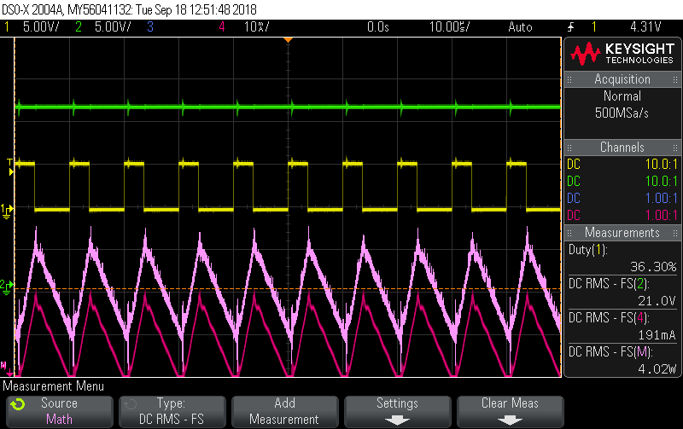

Figure 4: 0.5 A current limit (low end)

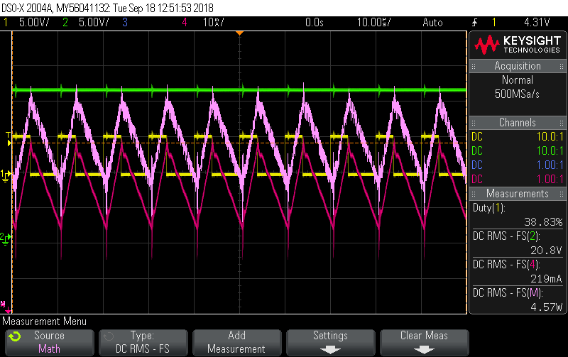

Figure 5: 0.5 A current limit (high end)

|  |  |  |  |
| --- | --- | --- | --- |
|  | **0.5 A** |  |  |
| **R(Ω)** | **I (A)** | **v(V)** | **P(W)** |
| 0 (SC) | 0.5 | 0 | 0 |
| 1 | 0.5 | 0.57 | 0.285 |
| 4.7 | 0.5 | 2.36 | 1.18 |
| 10 | 0.5 | 5.05 | 2.525 |
| 22 | 0.5 | 10.95 | 5.475 |
| 33 | 0.496 | 16.94 | 8.40224 |
| **47** | **0.435** | **20.33** | **8.84355** |
| 68 | 0.309 | 20.97 | 6.47973 |
| 100 | 0.21 | 20.98 | 4.4058 |
| 220 | 0.096 | 20.99 | 2.01504 |
| 270 | 0.079 | 20.99 | 1.65821 |
| O/C | 0 | 21 | 0 |

Figure 6: True MPP for 0.5 A current limit

Similarly, as seen in figures 4 and 5, the P&O MPPT was fluctuating between 4.02 and 4.57 W. This is similar to what we observed in the 0.4 A scenario, as these values are slightly off from what we identified as the true MPP in section 5.1.

It would appear that there are some imperfections in our P&O MPPT algorithm, as in both scenarios we were oscillating around values that were not quite accurate to the true maximum power point. Our code was still working to some degree, due to the fact that the duty cycle was changing and oscillating, however we must fix the algorithm to more accurately reflect and track the true MPP in order to achieve maximum efficiency.

iv) Suggest a way to improve the tracking accuracy of P&O.

One such way to improve the tracking accuracy of the P&O method would be to implement a stepping approach. This would be done by comparing the current voltage reading to the voltage desired at the MPP. If the current voltage is significantly different from the desired voltage, then the duty cycle will be changed by a larger stepping amount. Similarly, if the current voltage is only slightly different from the desired voltage, the duty cycle will only be altered by a smaller step. This would drastically improve the acquisition speed of the maximum power point as less time would be spent slowly increasing the duty cycle in order to steadily approach the MPP. As a result of this greatly increased tracking speed, the overall efficiency of the system would be improved and thus we would see an improvement to the tracking accuracy of the P&O algorithm.